**Applied Econometrics and Time Series Analysis**

**Project Report**

**Group 3**

Aashreya Reddy Pasham

Anantha Sai Sri Harsha Royaprolu

Travis William Burns

Vinod Kumar Reddy Desireddy

Sakruth Puskuri

**OBJECTIVE**

Our objective for this project was to investigate the relationship between suicide rates and GDP of 101 different countries over 32 years.

**INTRODUCTION**

Every year, close to 800,000 people die due to suicide. The consequence of the loss of these lives affects people of all different walks of life in cultures all around the world. It is estimated that for each adult who dies by suicide, there may be more than 20 others attempting to commit suicide. In 2016 alone, suicides accounted for 1.4% of overall deaths worldwide making it the 18th leading cause of death, 79% of those suicides having occurred in low and middle-income countries. Our team sought to understand the relationship between the economic conditions characterizing the quality of life in these countries and the consequent susceptibility to suicide that they stand to influence.

**DATA DESCRIPTION**

The dataset we’ve chosen is an unbalanced panel data which contains 27820 observations and 12 variables.

**List of variables-** country, year, sex, age, suicide_no, population, suicides.100k.pop, country. year, HDI.for.year, gdp_for_year, gdp_per_capita, generation.

**List of countries-** 'Albania', 'Antigua and Barbuda', 'Argentina', 'Armenia' ,'Aruba', 'Australia' ,'Austria' ,'Azerbaijan' ,'Bahamas', 'Bahrain' ,'Barbados', 'Belarus', 'Belgium', 'Belize' ,'Bosnia and Herzegovina', 'Brazil', 'Bulgaria', 'Cabo Verde' ,'Canada', 'Chile', 'Colombia', 'Costa Rica', 'Croatia', 'Cuba' ,'Cyprus', 'Czech Republic', 'Denmark', 'Dominica', 'Ecuador', 'El Salvador', 'Estonia', 'Fiji', 'Finland', 'France', 'Georgia', 'Germany', 'Greece', 'Grenada', 'Guatemala', 'Guyana', 'Hungary' ,'Iceland', 'Ireland', 'Israel', 'Italy', 'Jamaica', 'Japan', 'Kazakhstan', 'Kiribati', 'Kuwait', 'Kyrgyzstan', 'Latvia', 'Lithuania', 'Luxembourg', 'Macau', 'Maldives', 'Malta' ,'Mauritius', 'Mexico', 'Mongolia', 'Montenegro', 'Netherlands' ,'New Zealand', 'Nicaragua', 'Norway', 'Oman', 'Panama', 'Paraguay', 'Philippines', 'Poland', 'Portugal', 'Puerto Rico', 'Qatar' ,'Republic of Korea', 'Romania', 'Russian Federation', 'Saint Kitts and Nevis', 'Saint Lucia', 'Saint Vincent and Grenadines', 'San Marino', 'Serbia' ,'Seychelles', 'Singapore', 'Slovakia', 'Slovenia', 'South Africa' ,'Spain', 'Sri Lanka', 'Suriname', 'Sweden', 'Switzerland', 'Thailand', 'Trinidad and Tobago', 'Turkey', 'Turkmenistan', 'Ukraine', 'United Arab Emirates', 'United Kingdom' ,'United States', 'Uruguay', 'Uzbekistan’.

**Years -** 1987, 1988, 1989, 1992, 1993, 1994, 1995, 1996, 1997, 1998, 1999, 2000, 2001, 2002, 2003, 2004, 2005, 2006, 2007, 2008, 2009, 2010,1985, 1986, 1990, 1991, 2012, 2013, 2014, 2015, 2011, 2016.

**DATA PREPARATION**

The data is at country, year, sex and age level. We require the data to be at country, year level in order to analyze the impact of GDP on suicide rate using fixed effects model.

We have aggregated the data to country, year level and calculated the following variables.

* total_suicides = total absolute number of suicides happened in a country in that year.
* Population = total population of that country in that year.
* gdp_for_year = the absolute value of the GDP of that country in that year.
* Suicides_per100K = Number of suicides happened per 100K population in a country in that year.
* gdp_pc = the per capita GDP of a country in a given year.

gdp_pc is calculated as **gdp_for_year/population**

Suicides_per100K is calculated as **total_suicides/(population/100000)**

We want to analyze the effect of GDP on the suicides. For that we can take either gdp_for_year or gdp_pc as independent variable and either total_suicides or suicides_per100K as dependent variable.

There are no missing values in the dataset for any variable, but this data set is unbalanced i.e., the data is missing for some countries for some years. Since we couldn’t find any definitive pattern/reason for missing values, we can safely go ahead with the fixed effects model.

**EMPERICAL ANALYSIS**

Since we have the data for the same countries over different years, a first differences or fixed effects model would be most appropriate to estimating the effect of GDP on suicide rates.

If we regress number of suicides on gdp using fixed effects model, the time constant part of the error term which is most likely correlated with the independent variable GDP will be annulled as we will be taking the difference of each observation with the mean of that variable. Some of the time constant variables could be size of the country, the amount of land available for economic activity such as agriculture, the availability of natural and mineral resources, etc.

We can control for the population in two ways -

1. Including population in the regression equation if the dependent and independent variables are total_suicides and gdp_for_year respectively.
2. Instead of including population in the equation, we can use suicides_per_100k and gdp_pc and dependent and independent variables respectively.

We are using method 2 for the analysis

**Fixed Effects model**

suicidesct = B0 + B1*GDPct + ect

Where c = country, t = year and e = disturbance term or unobserved values

We can rewrite the error term as ect = ac + vct where ac is time constant part of the error term which depends only on country and does not change with time and vct is the time variant part of the error term which depends on country and time.

So, our model can be rewritten as suicidesct = B0 + B1*GDPct + ac + vct

When we take the difference of the model for different years, the time constant part of the error term ac will be nullified.

**Model – 1**

Dependent Variable- Suicides per 100k population

Independent Variable- log (GDP per capita)

Group Variable= Country

**Suicide_per_100k = 22.64 - 1.3516 * log(gdp_per_capita)**

According to this model, 1% increase in GDP per capita is expected to decrease suicides per 100k population by 0.0135 approximately.

The coefficient of l_gdp_pc is not significant as the t-statistic is –1.43, and p value is 0.156 which is greater than 0.05

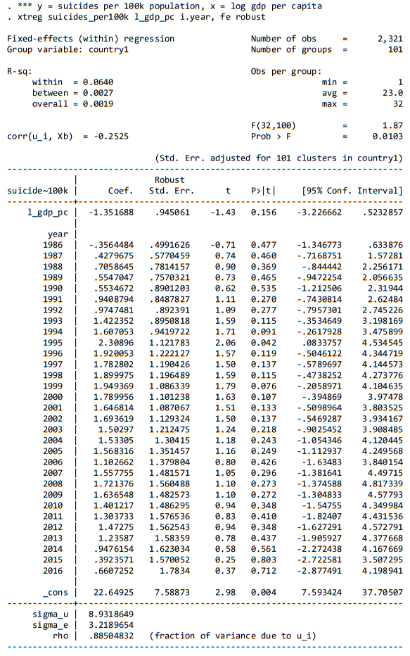

**CONCLUSION**

Although the grief felt by those who have lost loved ones to suicide can seem similar across different cases, suicide represents the culmination of an extremely complex group of behavioral factors of both an intrapersonal and societal nature. The rate of suicide is not only responsive to economic factors, such as GDP per capita or growth rate of GDP per capita, but also to social factors. It can be said that a higher GDP can result for an improved quality of life that generally tends to curve the rate of suicide for nuance. Since our model produced the results of a statistically insignificant correlation between GDP and suicide rates, it can be inferred that the real-world consequences of this relationship could be considered negligible and does not support any causal relationship between the GDP and suicide rates.

**CODE**

Stata code:

clear

use "C:\Users\vxd200006\Desktop\econ_project\suicides_gdp_data\suicides_with_log2.dta

encode country, gen(country1)

xtset country1 year

*** y = suicides per 100k population, x = gdp per capita

xtreg suicides_per100k gdp_pc i.year, fe robust

*** y = suicides per 100k population, x = log gdp per capita

xtreg suicides_per100k l_gdp_pc i.year, fe robust

**REFERENCE**

[Data Set Source](https://www.kaggle.com/russellyates88/suicide-rates-overview-1985-to-2016)

<https://www.who.int/teams/mental-health-and-substance-use/suicide-data>

<https://www.cambridge.org/core/journals/the-british-journal-of-psychiatry/article/relationship-of-suicide-rates-to-economic-variables-in-europe-20002011/BED5FCDDA918CE73A5390249B83F0C57/core-reader>